To : Hwy 36, Lake Brown Wood, Gorman Buffalo Gap, and Daugherty Street Churches Of Christ.

Subject: February Church Outreach Report

From: Patson and Marg Syula.

Dear brothers and sisters in Christ.
Greetings to you all in the name of our Lord and saviour Jesus Christ.
God our heavenly father has blessed us with a lot of rainfall.

FOUR PEOPLE REDEDICATED THEIR LIVES TO THE LORD- RIVERVIEW CHURCH.
On 20/02/23 I visited Riverview church of Christ. I had some series of leadership lessons and during worship service I preached and two ladies and two men came forward and requested some prayers for restoration and were prayed for and restored.
Riverview church is now one year and three months old and now has one hundred and thirty attenders including children.
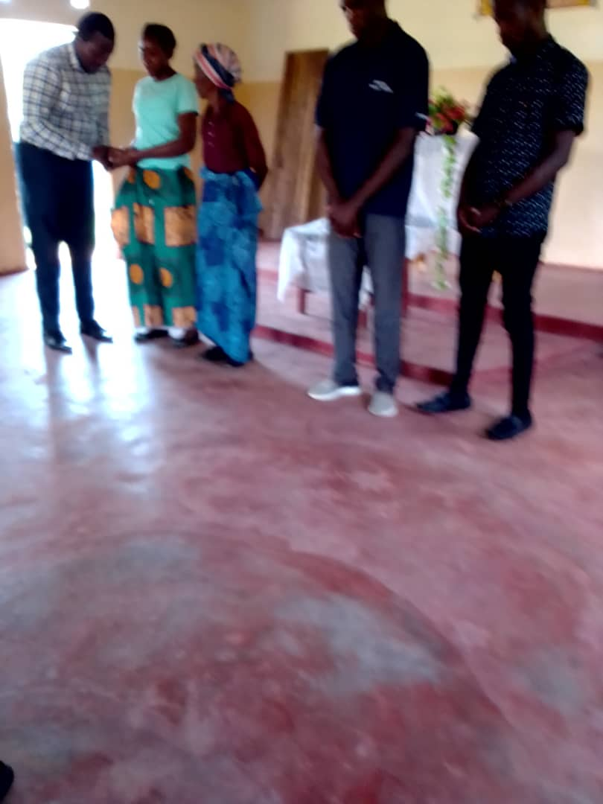
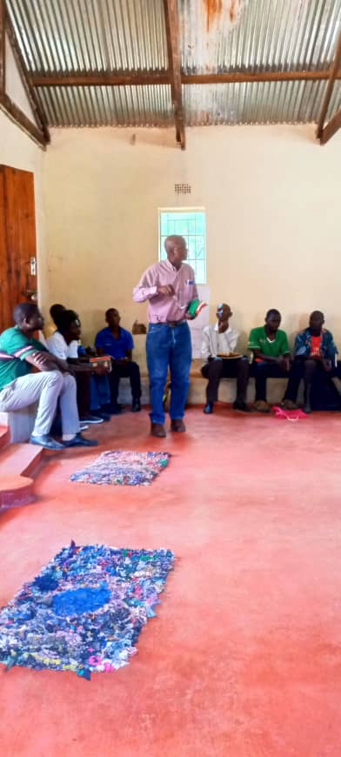
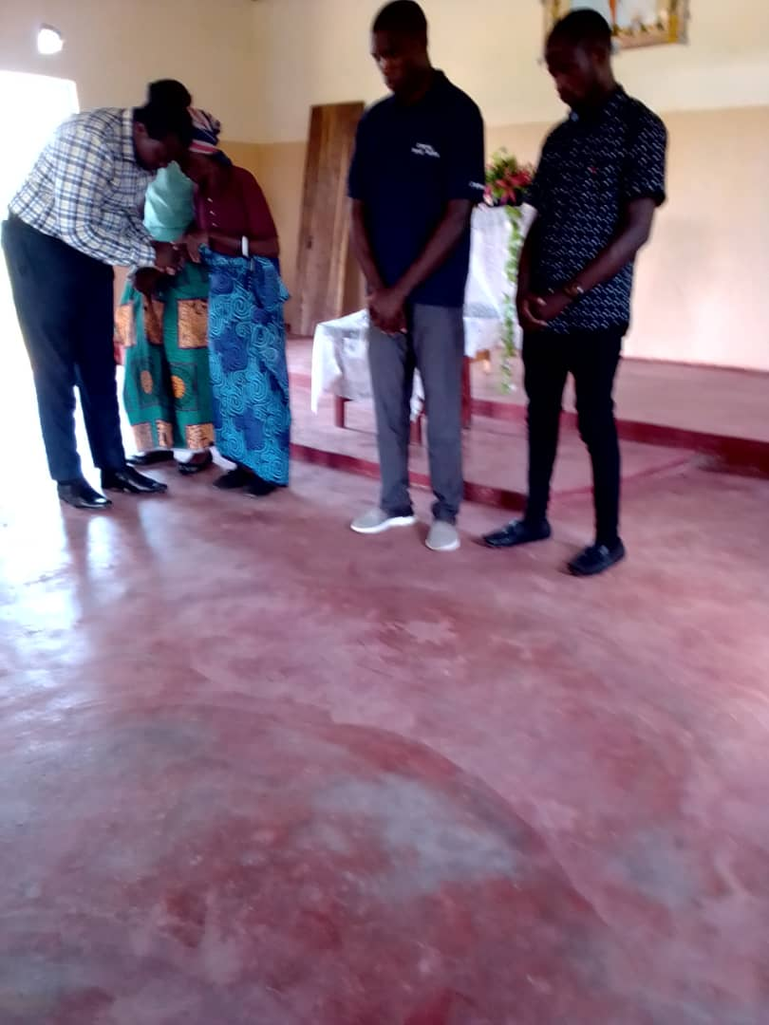

THREE SOULS BROUGHT TO THE LORD- OWL'S HILL CHURCH OF CHRIST GAME PARK AREA.
Brother Marshwell palija a man I work with in the game park area report three baptisms at Owl's hill church. They walked a distance of about 3km to water point to conduct baptism. Hence the new church is growing well.
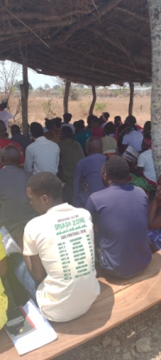
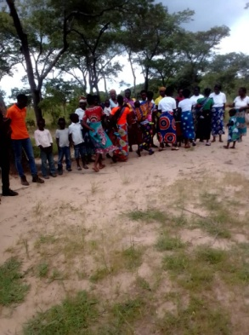

TWO PEOPLE REDEDICATED THEIR LIVES TO THE LORD- CHOONGA CHURCH
In 12/02/23 I visited Choonga church of Christ, and preached. Two men came forward and requested for restoration prayers and they were prayed for.
Choonga church during this part of the year has more members because of the high school students from the near by high school students who come to attend the worship services in large number.
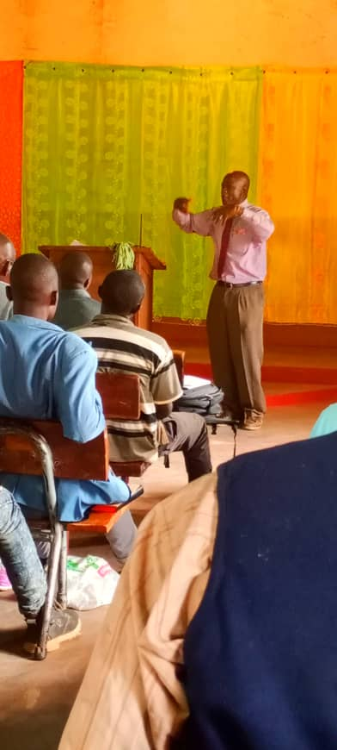
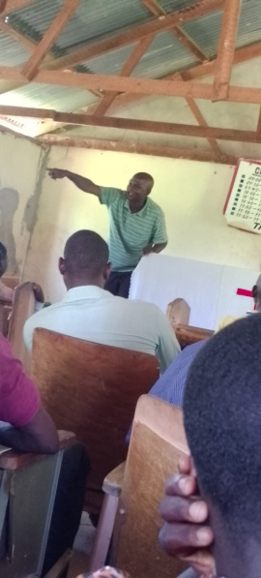

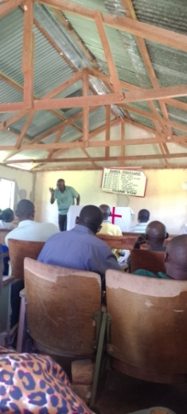

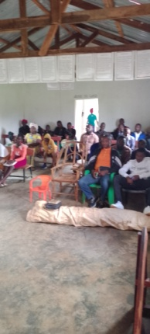

Thank you so much for being mission minded Churches, may our God almight keep blessing you.

Patson and marg Syula.

